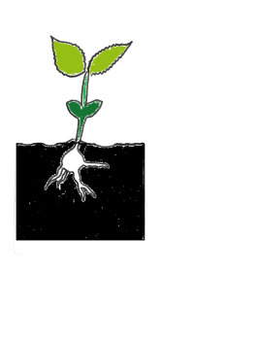

Cleaning

* Cleaning Cloths
* Spray & Wipe
* Toilet Cleaner
* Washing Powder
* Dishwashing Liquid

Toiletries

* Deodorant
* Soap
* Razors
* Toothpaste
* Toothbrush
* Toilet Paper
* Sanitary Pads/Tampons
* Nappies/Baby Wipes

**List of Useful Items for the**

**Mustard Seed Pantry**

Food

* Breakfast Cereals
* Long Life Milk
* LL Lactose Free Milk
* Lunch Box snacks
* Afternoon Tea treats
* Tinned Fish- tuna & salmon
* Tinned Fruit
* Tinned Vegetables/Legumes
* Biscuits- sweet & savoury

Saos, Rice Cakes, Cruskits

* Soups- tin & packet
* Dinner Meal Kits
* Rices & Pastas & Legumes
* Gluten Free Products

As a good exercise in the practice of being mindful to the needs of others, we encourage you to think about the food you eat and the products you use.

Think about what your favourite things are and that will give you a good idea what would be helpful and useful to someone else.